***CUCUMBER INSTALLATION***

**Steps:**

1. Go to Visual Studio Code.
2. From Extensions (ctrl+shift+x) we have to search and Install Cucumber(Gherkin) Full Support.

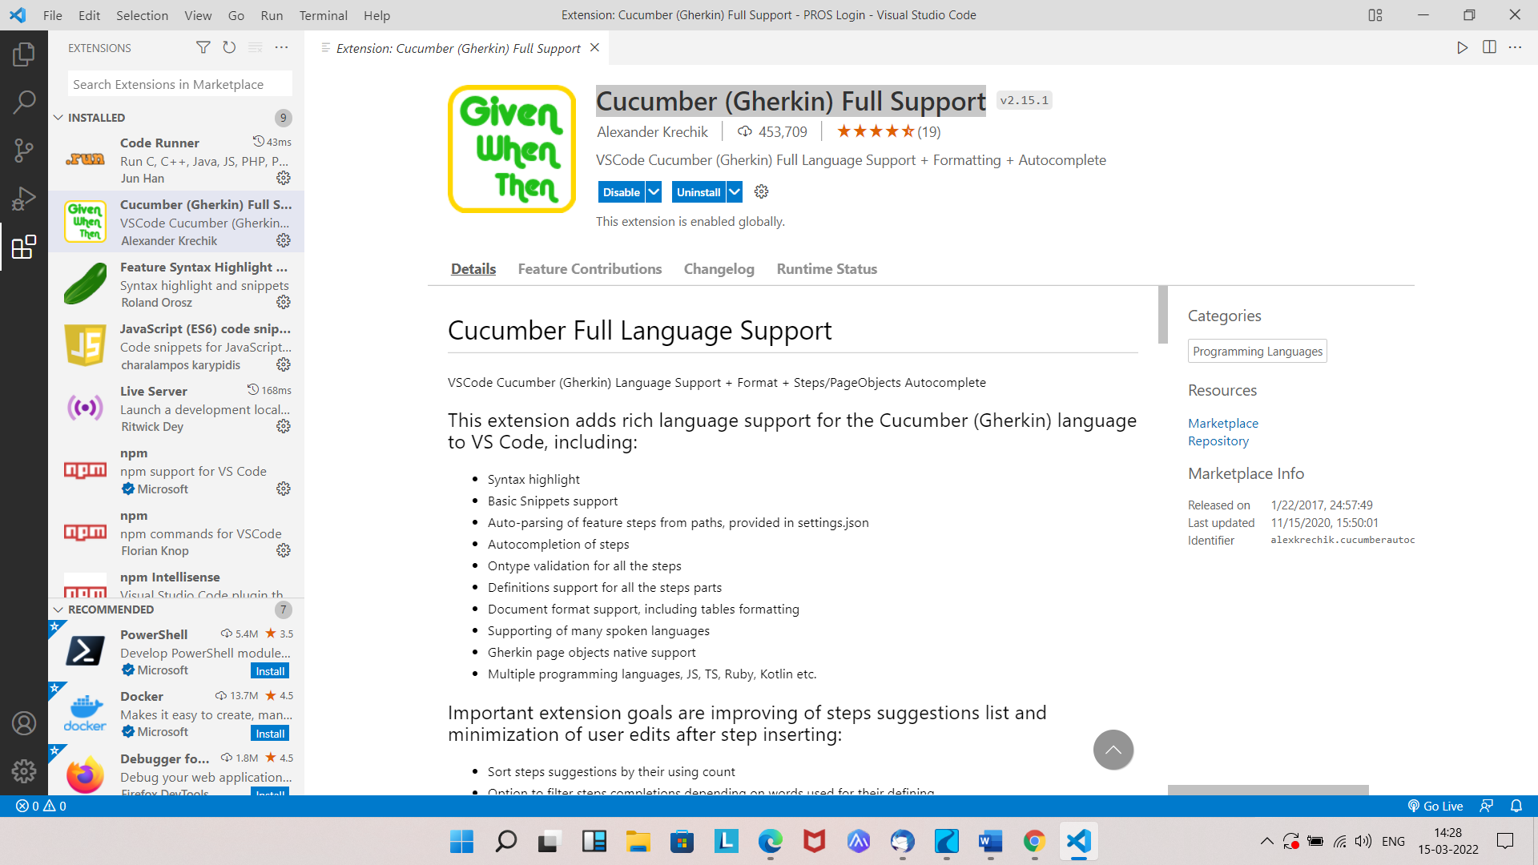

1. And we have to search and install Feature Syntax Highlight and Snippets (Cucumber/Gherkin).

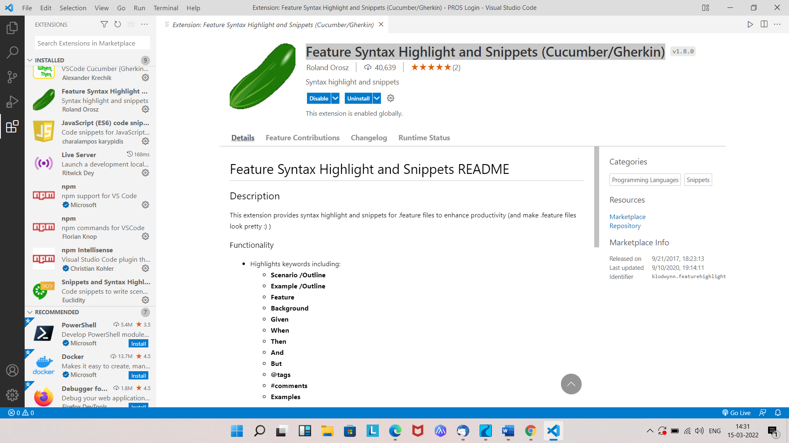

1. Then we have to install Snippets and Syntax Highlight for Gherkin (Cucumber) in the same extensions bar.

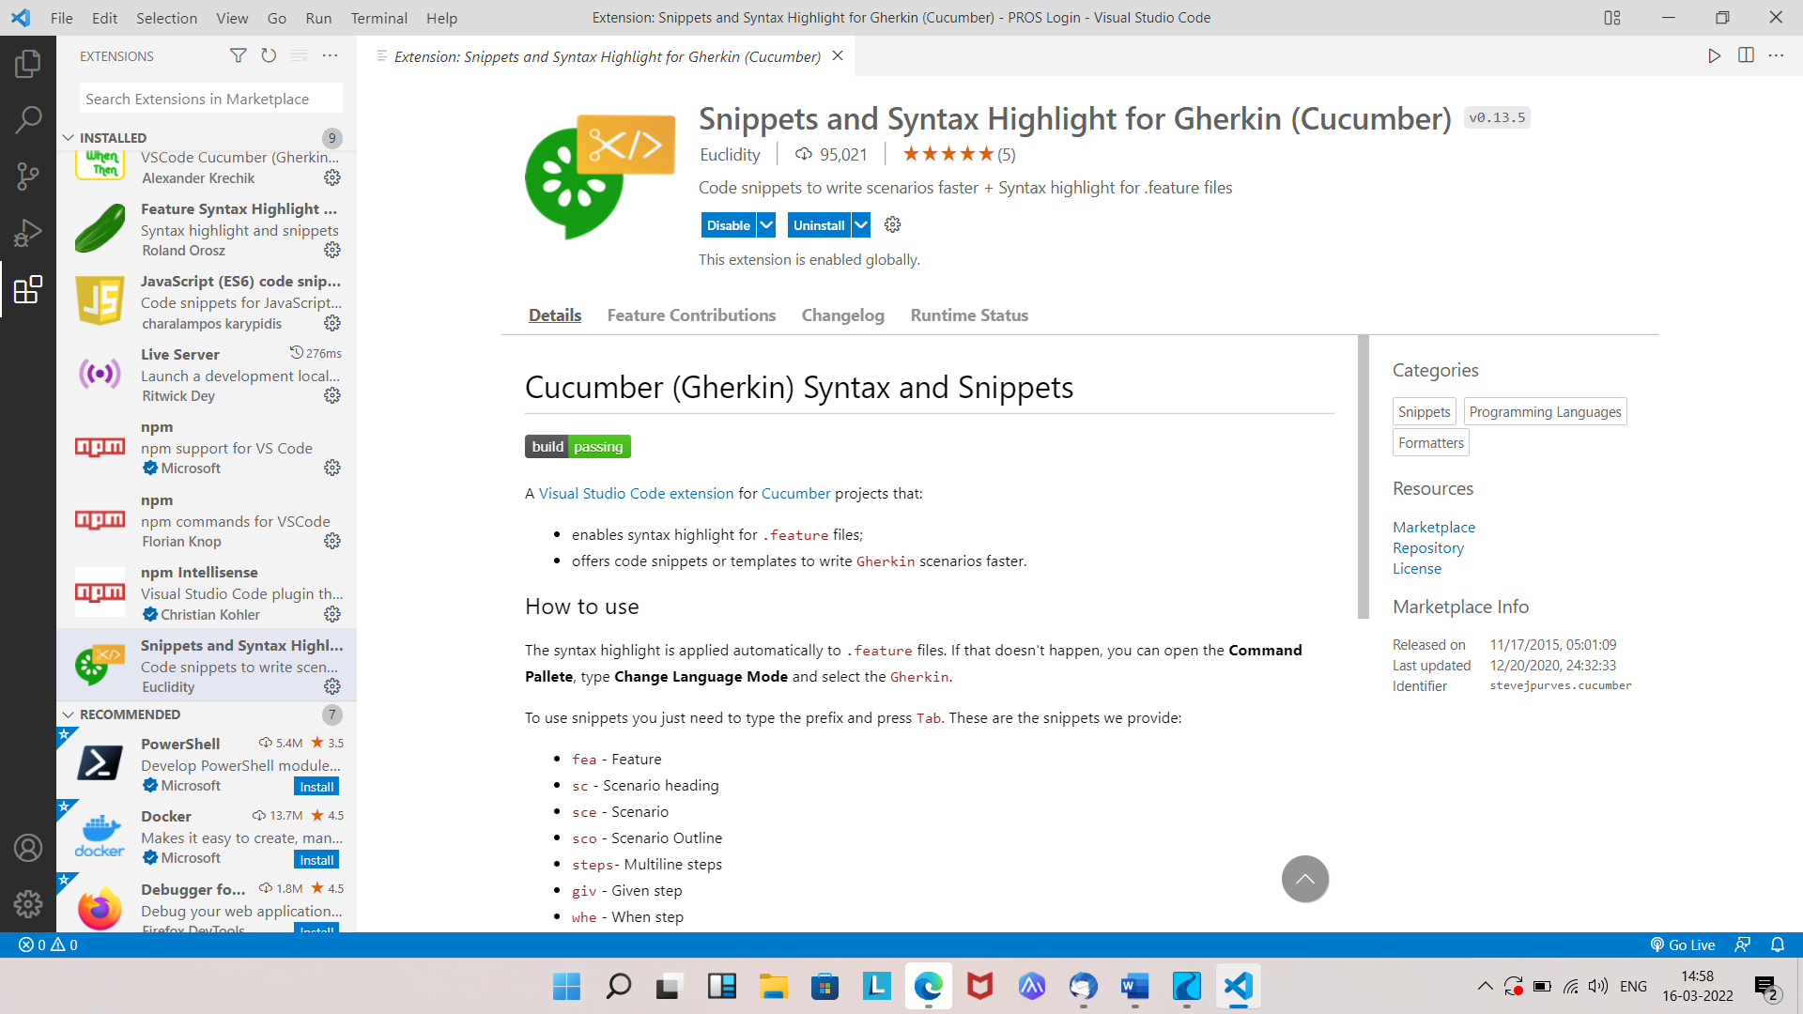

1. After the installation we have to create one folder in vscode.
2. After that go to New Terminal and enter the following command **npm init -y.** Then the Package.json file will be auto-created under the respected folder.

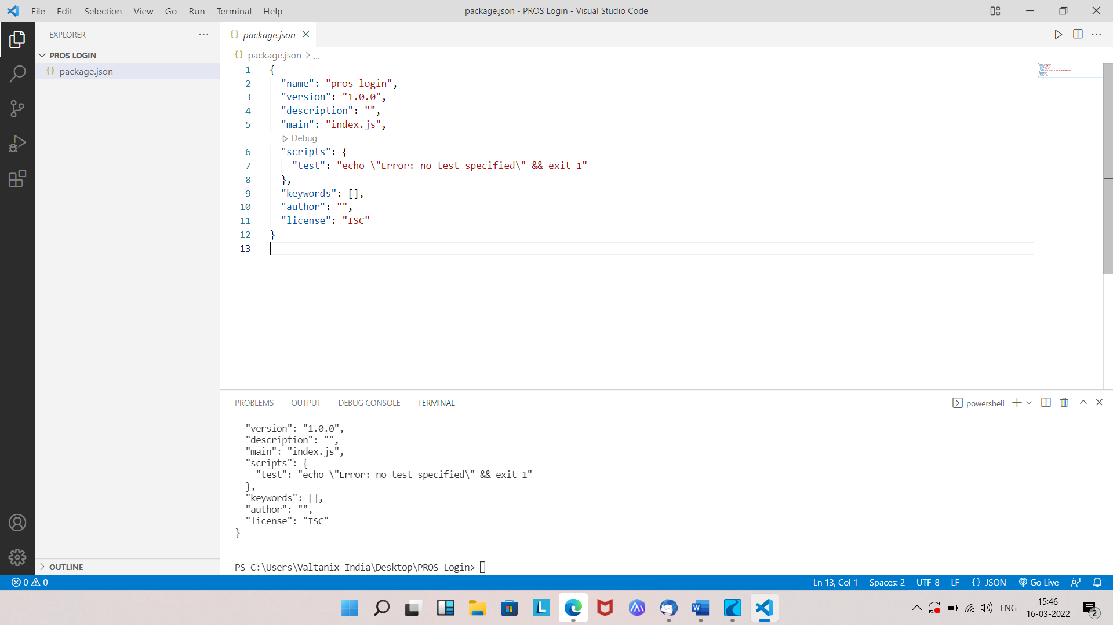

1. Then we have to run this command **npm install --save -dev @cucumber/cucumber** then node modules and package-lock.json file will be auto-create under the same folder.

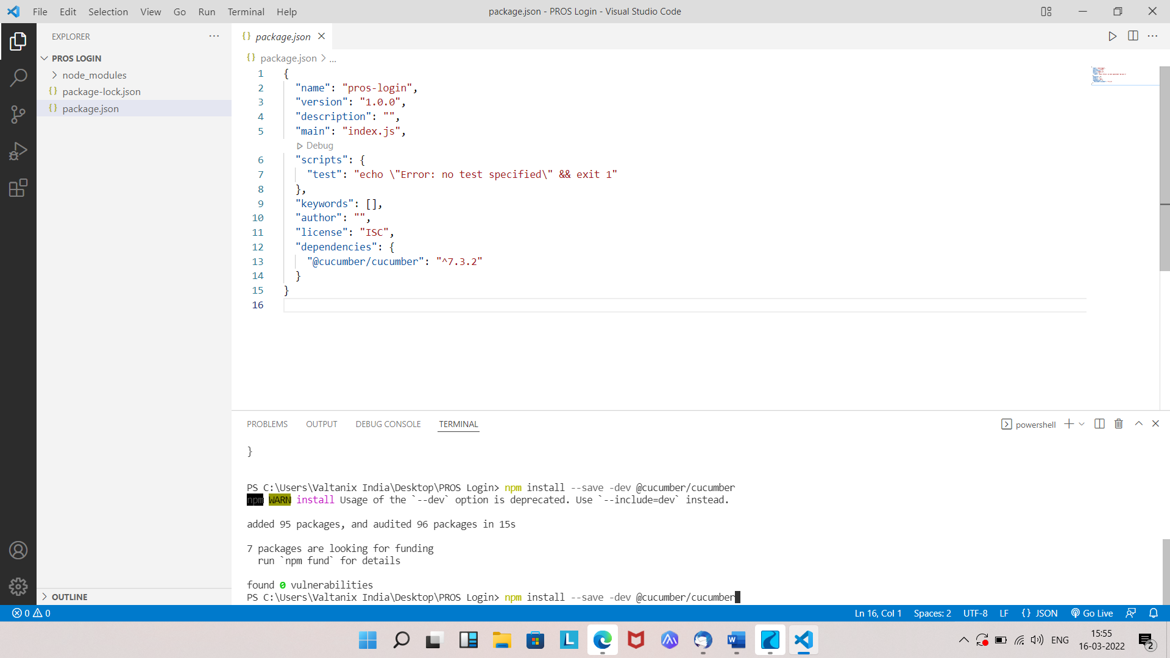

1. And then we have to run the command **npm install --save -dev chromedriver** to install chrome driver. (Note: we have to select which npm chromedriver version is suitable for our system)

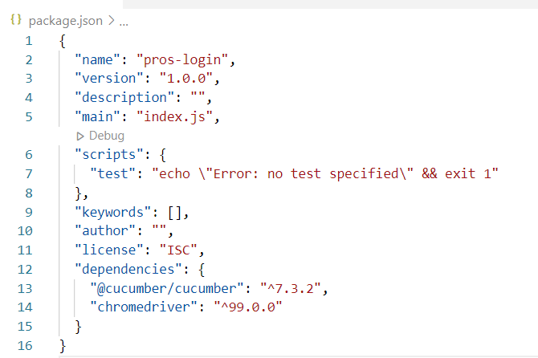

1. After that we have run the command **npm install --save -dev chai** to provide clean syntax that almost reads like English.

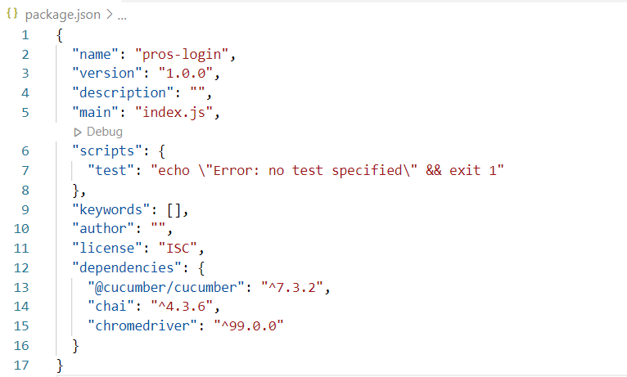

1. Then we have to run the command **npm install --save -dev selenium-webdriver** to install selenium webdriver.

